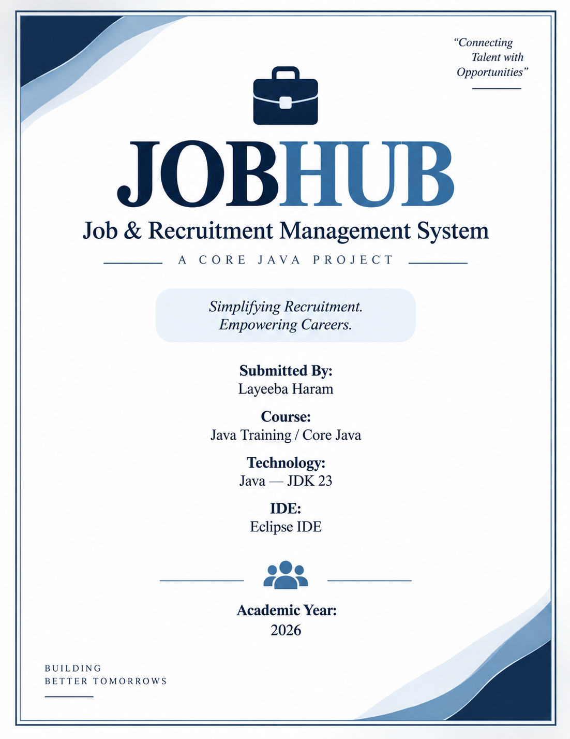

PROJECT REPORT
Job & Recruitment Management System
Project Information | Details
Project Name | JobHub
Project Type | Console-based Core Java Application
Language | Java
JDK | JDK 23
IDE | Eclipse IDE
Training Area | Java Training / Core Java
Submitted By | Layeeba Haram
Academic Year | 2026

Abstract
JobHub is a console-based Job and Recruitment Management System developed using Core Java. The application models a simplified recruitment workflow in which candidates and recruiters can be registered, companies can be associated with recruiters, jobs can be posted, candidates can search and apply for suitable jobs, interviews can be scheduled, and application statuses can be updated. The system also provides basic statistics.
The project is intentionally implemented without a database, external framework, or collection framework so that fundamental Core Java concepts remain visible in the implementation. It uses classes, objects, constructors, arrays, loops, conditional statements, switch statements, methods, method overloading, constructor overloading, encapsulation, inheritance, abstraction, runtime polymorphism, static members, type casting, strings, and input validation.
Keywords
Core Java • OOP • Recruitment • Candidates • Recruiters • Jobs • Applications • Interviews • Arrays • Validation

TABLE OF CONTENTS
No. | Section
1 | Introduction
2 | Objectives
3 | Problem Statement
4 | Scope and Features
5 | Technology and System Requirements
6 | System Workflow and Architecture
7 | Class and Module Description
8 | Core Java Concepts Demonstrated
9 | Testing and Validation
10 | Sample Execution / Output
11 | Advantages, Limitations and Future Scope
12 | Conclusion

1. INTRODUCTION
Recruitment involves several related activities such as maintaining candidate information, registering recruiters, publishing vacancies, receiving applications, arranging interviews, and recording selection decisions. Managing these activities manually can make information difficult to organize and track.
JobHub provides a small-scale software model of this process. The application is menu-driven and operates through the Eclipse console. Each important real-world entity is represented as a Java class, allowing the project to demonstrate object-oriented design while remaining simple enough for Core Java training.
2. OBJECTIVES
- Develop a practical console application using Core Java.
- Apply object-oriented programming principles to a real-world recruitment scenario.
- Register and manage candidate and recruiter information.
- Store company and job information using objects and arrays.
- Allow candidates to apply for jobs after checking experience and skill suitability.
- Schedule interviews and maintain interview results.
- Update application status such as Shortlisted, Rejected, and Selected.
- Demonstrate static and non-static members, constructors, overloaded methods, arrays, loops, conditions, strings, and type casting.
- Implement basic input validation through a reusable utility class.
3. PROBLEM STATEMENT
Design and implement a Core Java application that simulates the basic operations of a job recruitment portal. The system should maintain candidates, recruiters, companies, jobs, applications, and interviews, and should provide simple search, eligibility, status management, and statistical functions.
4. SCOPE AND FEATURES
The current version focuses on the core recruitment workflow and includes the following menu operations:
Menu | Feature | Purpose
1 | Candidate Registration | Register candidate profile, qualification, experience and skills.
2 | Recruiter Registration | Register recruiter and associated company details.
3 | Post a Job | Create a job with salary, experience and required skills.
4 | View Available Jobs | Display all currently stored jobs.
5 | Search Jobs | Search job titles using a keyword.
6 | Apply for a Job | Create an application after suitability checking.
7 | View Applications | Display stored application details.
8 | Schedule Interview | Create an interview for an application.
9 | View Interviews | Display scheduled interviews.
10 | Update Application Status | Change application status.
11 | View Statistics | Display counts of system objects.
0 | Exit | Terminate the application.

5. TECHNOLOGY AND SYSTEM REQUIREMENTS
5.1 Technology Stack
Component | Technology / Choice
Programming Language | Java
Java Version | JDK 23
Development Environment | Eclipse IDE
Application Type | Console / Command-Line Application
Data Storage | In-memory arrays
Database | Not used
Frameworks | None
External APIs | None
5.2 Functional Requirements
- The system must accept candidate registration details.
- The system must accept recruiter and company details.
- A recruiter must exist before a job can be posted.
- A job must contain title, location, salary, experience requirement and required skills.
- A candidate must satisfy the job's experience requirement and have at least one matching skill to apply.
- Applications must receive a unique application ID.
- Interviews must be associated with an existing application.
- Application status must be updateable.
- The system must display basic usage statistics.
5.3 Non-Functional Requirements
- Simple and easy-to-use console interface.
- Readable, modular object-oriented code.
- Basic validation for numeric values.
- No dependency on a database or external service.
- Suitable for demonstrating Core Java concepts in a training environment.
6. SYSTEM WORKFLOW AND ARCHITECTURE
6.1 Workflow
The overall workflow of JobHub is:
Step | Flow
1 | Start JobHub
2 | Register Candidate and/or Recruiter
3 | Create Company details and associate them with a Recruiter
4 | Post Job with requirements
5 | View or Search Jobs
6 | Select Candidate and Job
7 | Check experience and skill suitability
8 | Create Application
9 | Schedule Interview
10 | Update Application Status
11 | View Statistics
12 | Exit

6.2 High-Level Architecture
Layer / Area | Implementation
User Interface | Main.java — menu-driven console
Validation | InputValidator.java — reusable static validation methods
Management | JobPortal.java — arrays, counts, search and lookup operations
Domain Model | Person, Candidate, Recruiter, Company, Job, Application, Interview
Storage | Fixed-size object arrays maintained in JobPortal

6.3 Class Relationship Overview
Person is the abstract base class for Candidate and Recruiter. Recruiter is associated with a Company and can post a Job. A Job refers to its Recruiter. An Application refers to both a Candidate and a Job. An Interview refers to an Application.
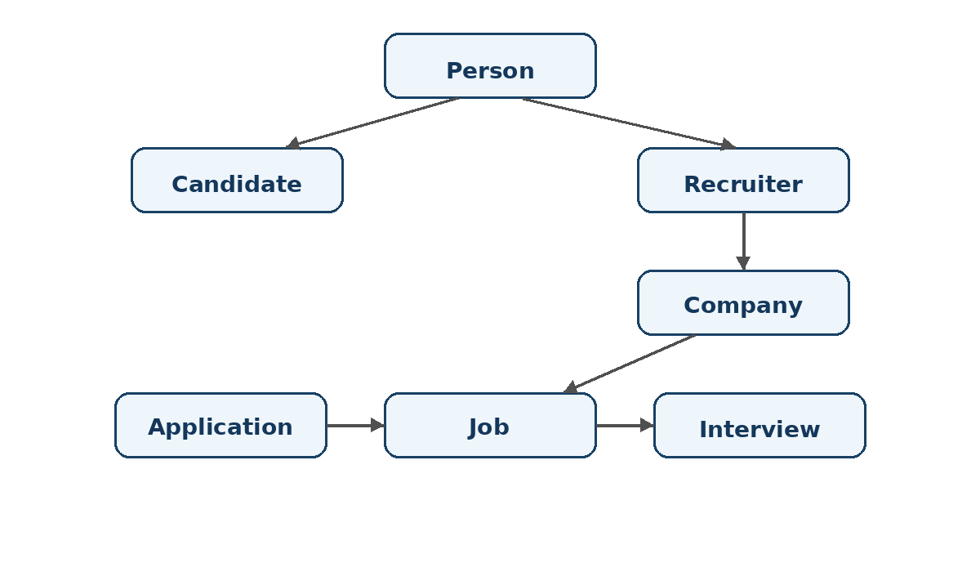

7. CLASS AND MODULE DESCRIPTION
Class | Responsibility | Key Concepts
Person | Abstract base class containing common personal information. | Abstraction, encapsulation, static member, constructor
Candidate | Stores qualification, experience and skills; checks skill matches. | Inheritance, overriding, arrays, method overloading
Recruiter | Stores recruiter details and associated company; posts jobs. | Inheritance, composition/association, methods
Company | Stores company identity, location and industry. | Class, object, constructor
Job | Stores job details and requirements; checks candidate suitability. | Objects, arrays, loops, type casting
Application | Connects a candidate to a job and maintains status. | Object relationships, encapsulation
Interview | Connects to an application and maintains interview result. | Object relationships, conditional logic
JobPortal | Maintains object arrays, counts, search and management operations. | Arrays, loops, methods, objects
InputValidator | Provides reusable validation methods. | Static methods, conditions
Main | Provides the menu-driven user interface and controls program flow. | Scanner, switch, loops, conditions
7.1 Important Object Relationships
- Inheritance: Candidate and Recruiter extend Person.
- Recruiter–Company association: a recruiter is linked to a company object.
- Recruiter–Job association: a job stores the recruiter who posted it.
- Application–Candidate association: an application stores the candidate who applied.
- Application–Job association: an application stores the selected job.
- Interview–Application association: an interview stores the application for which the interview is scheduled.
7.2 Data Structures Used
Data Structure | Example | Purpose
String[] | Candidate skills | Store multiple skills for a candidate.
String[] | Job requiredSkills | Store skills required for a job.
Candidate[] | JobPortal candidates | Store registered candidates.
Recruiter[] | JobPortal recruiters | Store registered recruiters.
Job[] | JobPortal jobs | Store posted jobs.
Application[] | JobPortal applications | Store submitted applications.
Interview[] | JobPortal interviews | Store scheduled interviews.

8. CORE JAVA CONCEPTS DEMONSTRATED
Concept | Where Demonstrated | Explanation
Variables & Data Types | All classes | int, double, String, boolean and arrays store program data.
Operators | Comparisons and validation | Arithmetic and relational operators are used in calculations and conditions.
Methods | All classes | Behavior is organized into reusable methods.
Method Overloading | Candidate | hasSkill(String) and hasSkill(String[]) provide different parameter lists.
Constructors | All model classes | Objects are initialized through constructors.
Constructor Overloading | Candidate, Job | Alternative constructors provide simpler object creation.
Encapsulation | Person and model classes | Fields are private and accessed through methods.
Inheritance | Candidate, Recruiter | Both extend the Person base class.
Abstraction | Person | Person is abstract and declares abstract displayDetails().
Polymorphism | displayDetails() | Overridden methods execute according to the actual object.
Static Members | Person, InputValidator | Shared person count and utility methods are static.
Conditional Statements | Eligibility, validation, status | if/else controls decisions.
Switch Statement | Main menu | Selects the requested operation.
Loops | Skills, searches, displays | for loops process arrays and stored objects.
Arrays | Skills and portal storage | Fixed-size arrays store multiple values/objects.
Strings | Names, skills, search, status | String methods support text handling and searching.
Type Casting | Job.getSalaryAsInteger() | double salary is explicitly cast to int.
Input Validation | InputValidator | Numeric and text checks reduce invalid input.
8.1 Example: Inheritance and Abstraction
public abstract class Person {
private int id;
private String name;
public abstract void displayDetails();
}
public class Candidate extends Person {
@Override
public void displayDetails() {
System.out.println("Candidate Details");
}
}

8.2 Example: Method Overloading
public boolean hasSkill(String skill) {
for (String candidateSkill : skills) {
if (candidateSkill.equalsIgnoreCase(skill)) {
return true;
}
}
return false;
}
public boolean hasSkill(String[] requiredSkills) {
int matchCount = 0;
for (String requiredSkill : requiredSkills) {
if (hasSkill(requiredSkill)) {
matchCount++;
}
}
return matchCount > 0;
}

8.3 Example: Type Casting
public int getSalaryAsInteger() {
return (int) salary;
}

9. TESTING AND VALIDATION
The application was tested through the complete menu-driven workflow. The test sequence included registration, job posting, job viewing/search, application, interview scheduling, status update, statistics and exit.
Test Case | Input / Action | Expected Result | Observed Result
TC01 | Register candidate | Candidate stored successfully | Passed
TC02 | Register recruiter + company | Recruiter stored successfully | Passed
TC03 | Post a valid job | Job stored successfully | Passed
TC04 | View available jobs | Job details displayed | Passed
TC05 | Search for Java | Matching job displayed | Passed
TC06 | Apply with matching experience/skill | Application submitted | Passed
TC07 | View applications | Application details displayed | Passed
TC08 | Schedule interview | Interview scheduled | Passed
TC09 | View interviews | Interview details displayed | Passed
TC10 | Update status to Selected | Status updated | Passed
TC11 | View statistics | Counts displayed correctly | Passed
TC12 | Exit | Program terminates normally | Passed
9.1 Validation Rules
- Candidate experience cannot be negative.
- Candidate skill count must be greater than zero.
- Job salary must be greater than zero.
- Required job experience cannot be negative.
- Required skill count must be greater than zero.
- A job cannot be posted until a recruiter has been registered.
- A candidate cannot apply if the candidate ID does not exist.
- A job cannot be selected if the job ID does not exist.
- An interview cannot be scheduled if the application ID does not exist.
9.2 Eligibility Logic
A candidate is considered suitable for a job when the candidate's experience is at least the required experience and at least one candidate skill matches one of the required job skills. Skill comparison is case-insensitive.

10. SAMPLE EXECUTION / OUTPUT
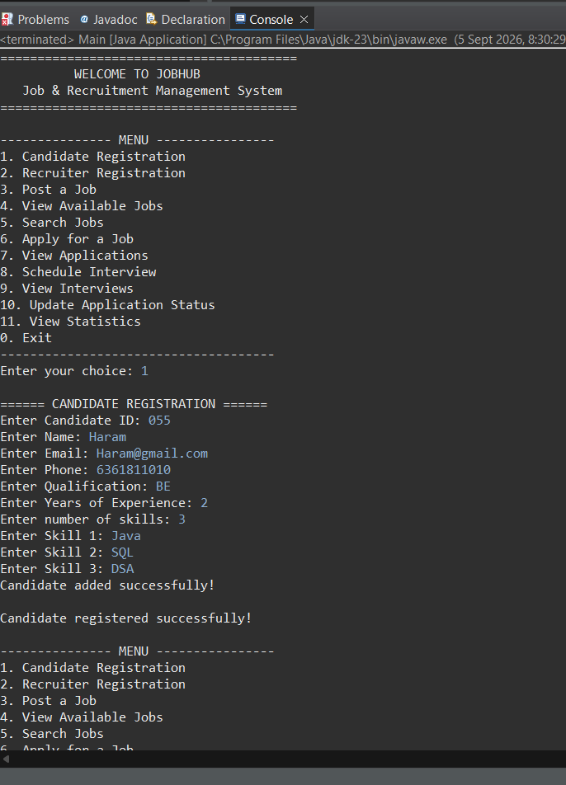
The following test data was used during the final end-to-end execution:
Entity | Sample Data
Candidate | ID 101 — Layeeba — BE Computer Science — 1 year
Candidate Skills | Java, SQL, Python
Recruiter | ID 201 — Rahul Sharma — HR Manager
Company | ID 301 — TechCorp Solutions — Bangalore — Information Technology
Job | ID 501 — Java Developer — ₹600000 — 0 years experience
Required Skills | Java, SQL
Application | ID 1 — Candidate 101 applied to Job 501
Interview | ID 1 — Online — 10-09-2026
Final Status | Selected
Final statistics output from the successful execution:

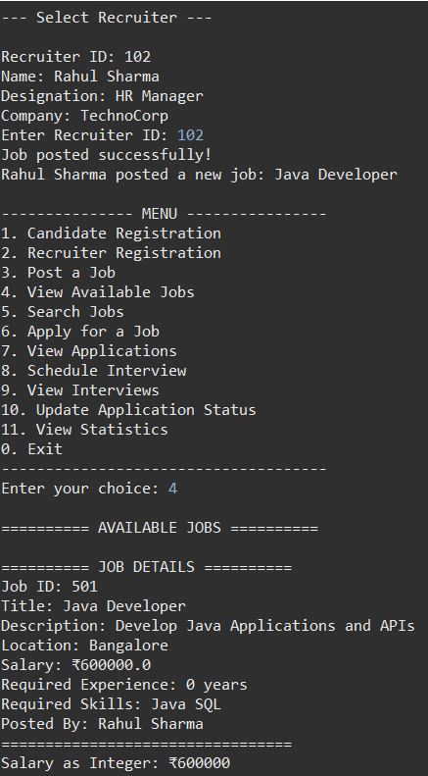
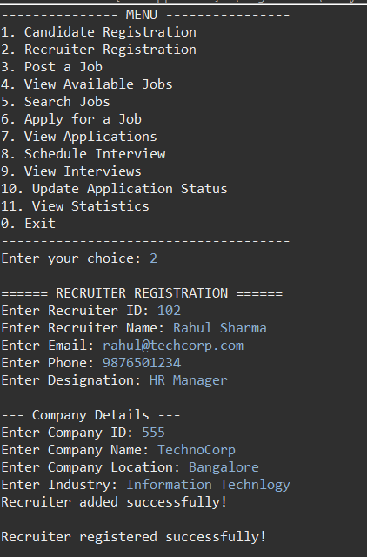

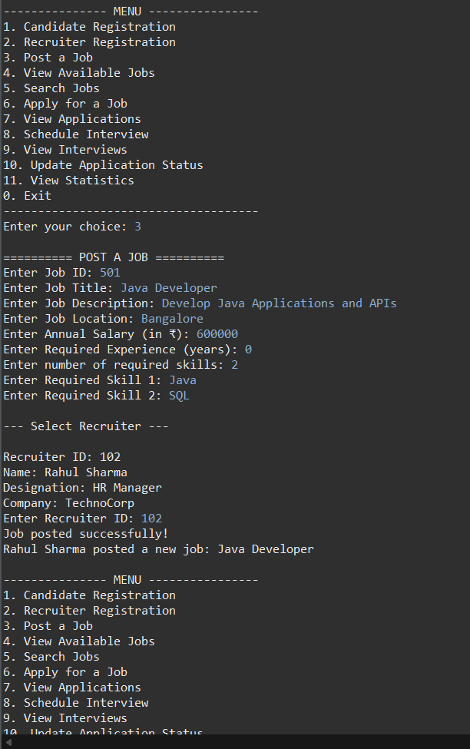

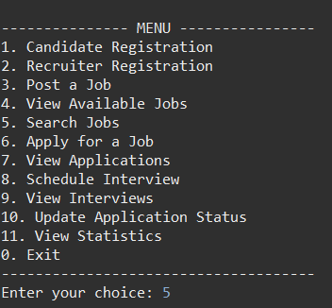

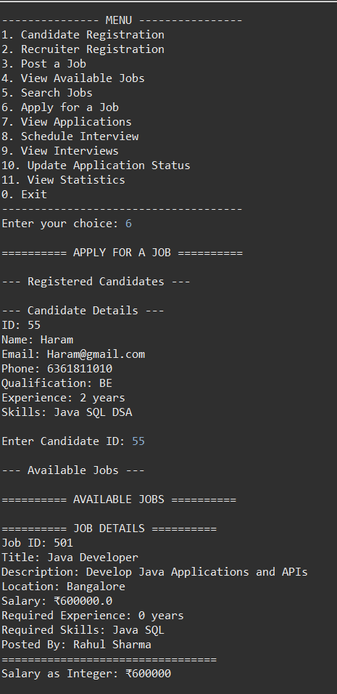
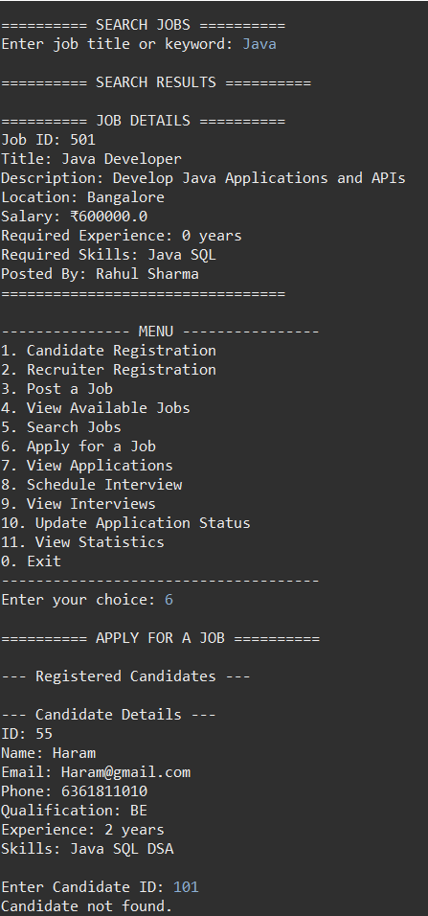

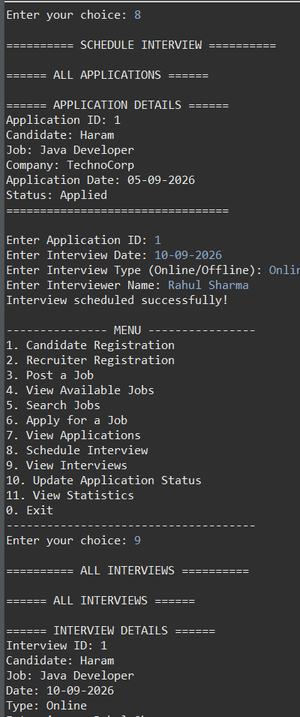
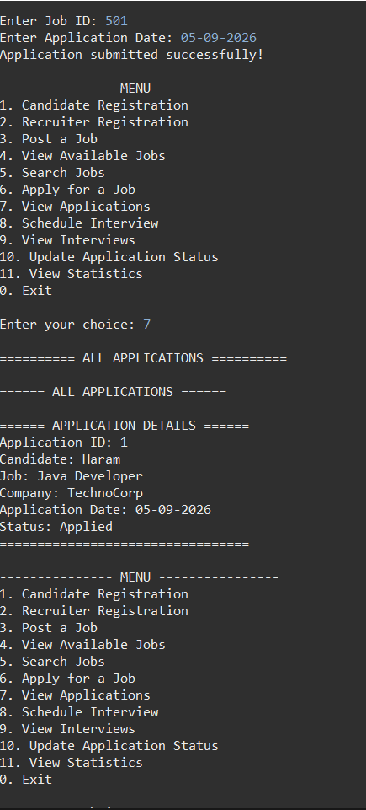

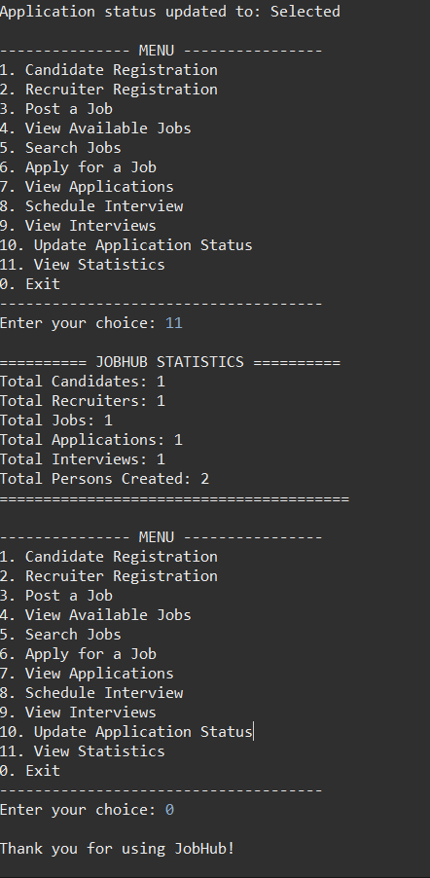
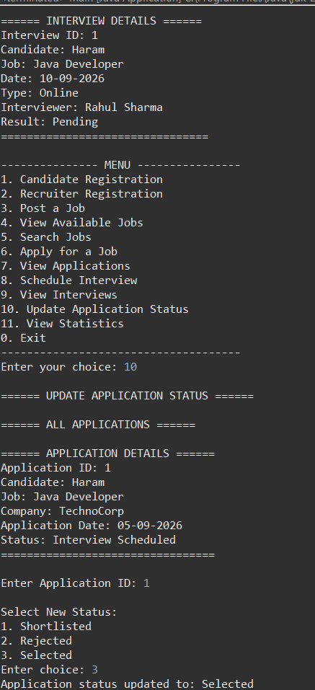

11. ADVANTAGES, LIMITATIONS AND FUTURE SCOPE
11.1 Advantages
- Simple menu-driven interface.
- Demonstrates many Core Java concepts in one practical project.
- Object-oriented structure makes responsibilities easy to understand.
- Basic eligibility checking prevents unsuitable applications.
- Reusable validation methods improve code organization.
- No external software or database is required to run the basic version.
11.2 Limitations
- Data is stored only in memory and is lost when the application terminates.
- Fixed-size arrays limit the number of stored records.
- The current interface is console-based.
- There is no authentication or role-based access control.
- Search currently focuses on job title keywords.
- No persistent database or online deployment is included.
11.3 Future Scope
- Replace fixed-size arrays with ArrayList and other Java Collections.
- Add MySQL or another database for persistent storage.
- Build a graphical or web interface.
- Add login and role-based authentication for candidates and recruiters.
- Add advanced job search filters such as location, salary, experience and skills.
- Add email or notification functionality for interviews.
- Generate recruitment reports and analytics.
- Deploy the application as a full-stack recruitment platform.

12. CONCLUSION
JobHub successfully demonstrates the development of a practical recruitment management application using Core Java. The project converts real-world entities such as candidates, recruiters, jobs, applications and interviews into Java objects and connects them through object relationships.
The completed application demonstrates fundamental programming constructs together with major object-oriented concepts, including encapsulation, inheritance, abstraction, polymorphism, constructor overloading and method overloading. The successful end-to-end execution confirms that the main recruitment workflow operates correctly.
Overall, JobHub provides a strong training-level example of how Core Java concepts can be combined to create a structured, functional and understandable software application.
APPENDIX A — PROJECT FILE STRUCTURE
JobHub/
└── src/
└── com/
└── jobhub/
├── Application.java
├── Candidate.java
├── Company.java
├── InputValidator.java
├── Interview.java
├── Job.java
├── JobPortal.java
├── Main.java
├── Person.java
└── Recruiter.java

APPENDIX B — FINAL MENU
1. Candidate Registration
2. Recruiter Registration
3. Post a Job
4. View Available Jobs
5. Search Jobs
6. Apply for a Job
7. View Applications
8. Schedule Interview
9. View Interviews
10. Update Application Status
11. View Statistics
0. Exit

***********************************

